Chapter 8 Problems

Assignment 9

Swapnil Shashikant Kamate

1. Write the SQL code that will create only the table structure for a table named EMP_1. This table will be a subset of the EMPLOYEE table. The basic EMP_1 table structure is summarized in the following table. Use EMP_NUM as the primary key. Note that the JOB_CODE is the FK to JOB so be certain to enforce referential integrity. Your code should also prevent null entries in EMP_LNAME and EMP_FNAME.

Answer:

CREATE TABLE EMP_1 (

EMP_NUM CHAR(3) PRIMARY KEY,

EMP_LNAME VARCHAR(15),

EMP_FNAME VARCHAR(15),

EMP_INITIAL CHAR(1),

EMP_HIREDATE DATE,

JOB_CODE VARCHAR(20)

CONSTRAINT F_K1 FOREIGN KEY (JOB_CODE)

REFERENCES JOB (JOB_CODE)

);

Note: I have used data type of Varchar for Job_code because the parent table was already created while performing assignment7 questions. MS SQL server will throw error if use different data type while referencing the existing table.

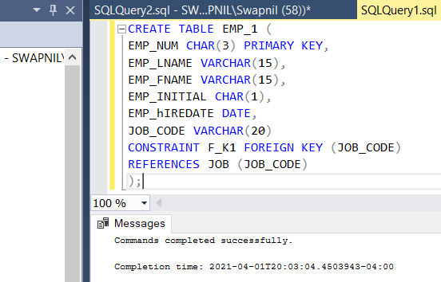

1. Having created the table structure in Problem 1, write the SQL code to enter the first two rows for the table shown in Figure P8.2. Each row should be inserted individually, without using a subquery. Insert the rows in the order that they are listed in the figure.

Answer:

INSERT INTO EMP_1 VALUES('101','News','John','G','11/08/2000','502');

INSERT INTO EMP_1 VALUES('102','Senior','David','H','07/12/1989','501');

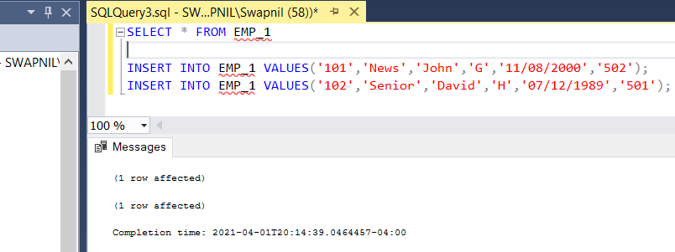

1. Using the EMPLOYEE table that already exists, use a subquery to insert the remaining rows from the EMPLOYEE table into the EMP_1 table. Remember, your subquery should only retrieve the columns needed for the EMP_1 table and only the employees shown in the figure.

Answer:

INSERT INTO EMP_1 (EMP_NUM,EMP_LNAME,EMP_FNAME,EMP_INITIAL,EMP_hIREDATE,JOB_CODE)

SELECT EMP_NUM,EMP_LNAME,EMP_FNAME,EMP_INITIAL,EMP_HIREDATE,JOB_CODE

FROM EMPLOYEE

WHERE EMP_NUM in ('103','104','105','106','107','108','109');

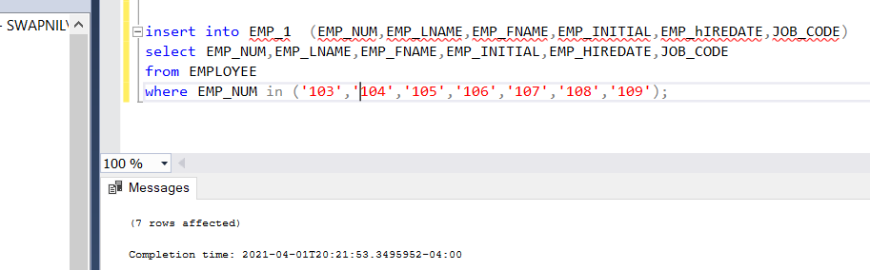

Verification:

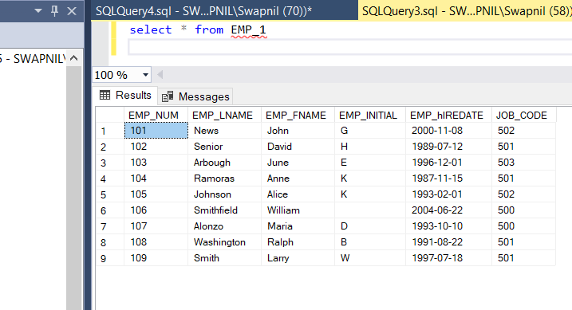

1. Write the SQL code that will save the changes made to the EMP_1 table (if supported by your DBMS).

Answer:

As I mentioned previously, I am using MS SQL server to run my queries. SQL Server unlike

Oracle does not require commits unless we are using transactions. Although the syntax for commit is: - COMMIT;

1. Write the SQL code to change the job code to 501 for the person whose employee number (EMP_NUM) is 107.

Answer:

UPDATE EMP_1

SET JOB_CODE = '501'

WHERE EMP_NUM ='107'

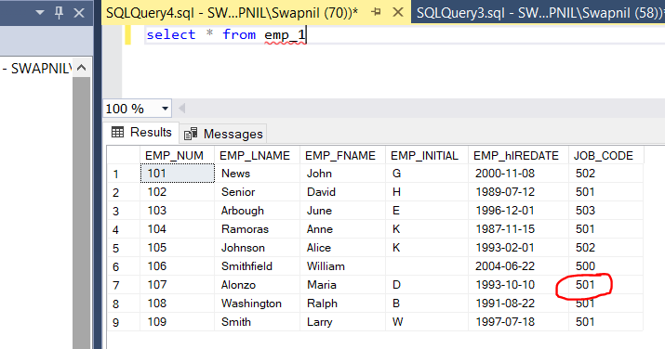

1. Write the SQL code to delete the row for William Smithfield, who was hired on June 22, 2004, and whose job code is 500. (Hint: Use logical operators to include all of the information given in this problem. Remember, if you are using MySQL, you will have to first disable “safe mode.”)

Answer:

DELETE FROM EMP_1

WHERE EMP_hIREDATE = '6/22/2004' AND JOB_CODE = '500';

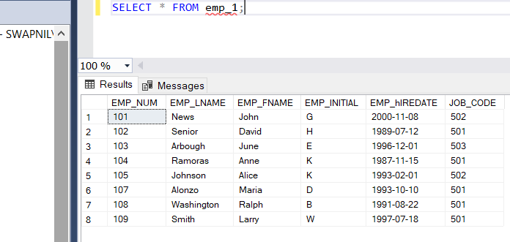

1. Write the SQL code to create a copy of EMP_1, including all of its data, and naming the copy EMP_2.

Answer:

CREATE TABLE EMP_2 (

EMP_NUM CHAR(3) PRIMARY KEY,

EMP_LNAME VARCHAR(15),

EMP_FNAME VARCHAR(15),

EMP_INITIAL CHAR(1),

EMP_HIREDATE DATE,

JOB_CODE VARCHAR(20)

CONSTRAINT F_K2 FOREIGN KEY (JOB_CODE)

REFERENCES JOB (JOB_CODE)

);

INSERT INTO EMP_2 SELECT * FROM EMP_1;

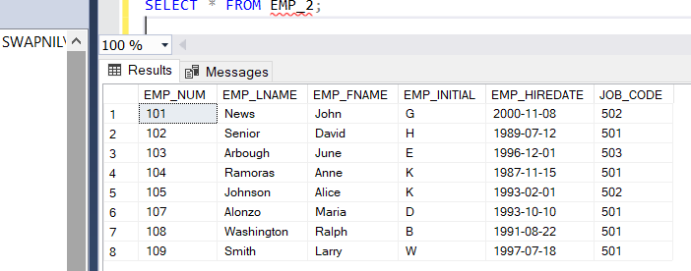

1. Using the EMP_2 table, write the SQL code that will add the attributes EMP_PCT and PROJ_NUM to EMP_2. The EMP_PCT is the bonus percentage to be paid to each employee. The new attribute characteristics are: EMP_PCT NUMBER (4,2) PROJ_NUM CHAR(3) Note: If your SQL implementation requires it, you may use DECIMAL(4,2) or NUMERIC(4,2) rather than NUMBER(4,2).

Answer:

ALTER TABLE EMP_2

ADD

EMP_PCT NUMERIC(4,2),

PROJ_NUMBER CHAR(3);

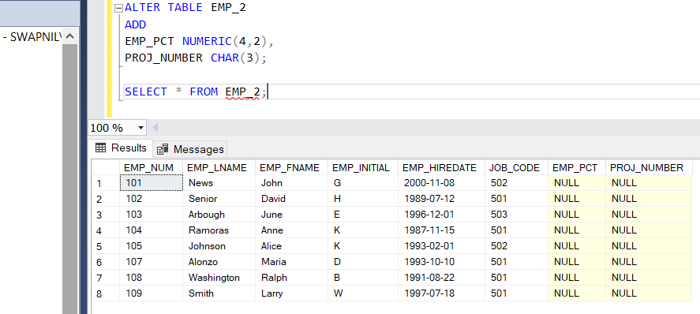

1. Using the EMP_2 table, write the SQL code to change the EMP_PCT value to 3.85 for the person whose employee number (EMP_NUM) is 103.

Answer:

UPDATE EMP_2

SET EMP_PCT =3.85

WHERE EMP_NUM = '103';

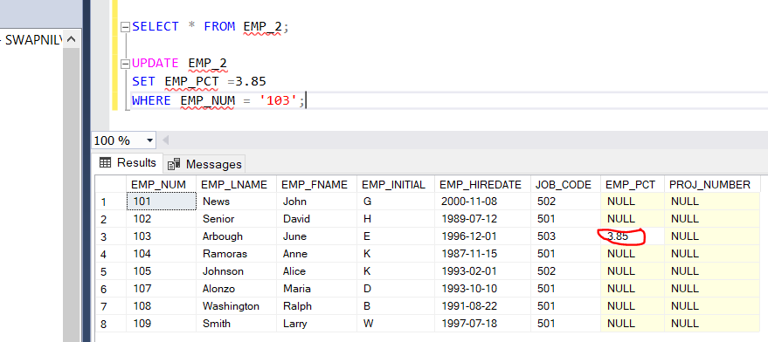

1. Using the EMP_2 table, write a single SQL command to change the EMP_PCT value to 5.00 for the people with employee numbers 101, 105, and 107.

Answer:

UPDATE EMP_2

SET EMP_PCT =5.00

WHERE EMP_NUM IN('101','105','107');

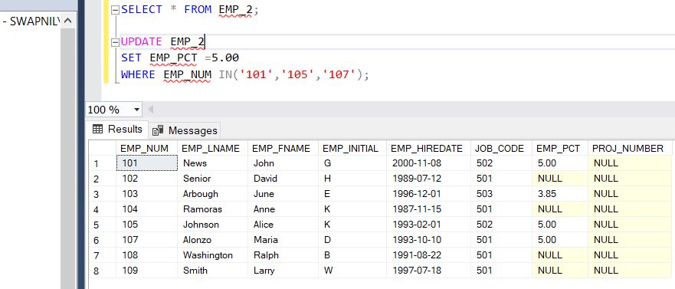

1. Using the EMP_2 table, write a single SQL command to change the EMP_PCT value to 10.00 for all employees who do not currently have a value for EMP_PCT.

Answer:

UPDATE EMP_2

SET EMP_PCT =10.00

WHERE EMP_PCT IS NULL;

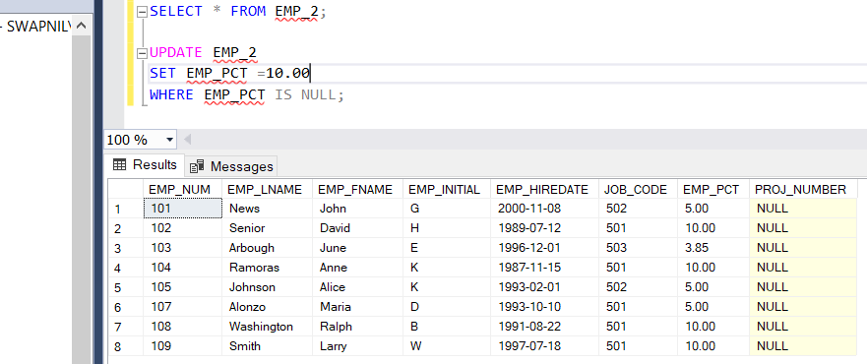

1. Using the EMP_2 table, write the SQL command to add .15 to the EMP_PCT of the employee whose name is Maria D. Alonzo. (Use the employee’s name in your command to determine the correct employee.)

Answer:

UPDATE EMP_2

SET EMP_PCT = EMP_PCT + 0.15

WHERE EMP_FNAME ='Maria' and EMP_LNAME ='Alonzo';

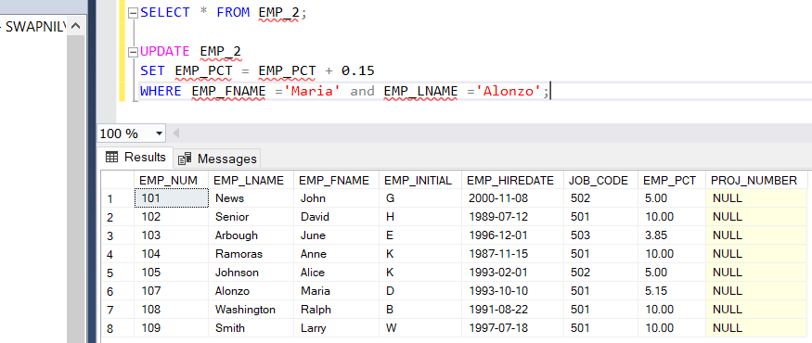

1. Using a single command sequence with the EMP_2 table, write the SQL code that will change the project number (PROJ_NUM) to 18 for all employees whose job classification (JOB_CODE) is 500.

Answer:

UPDATE EMP_2

SET PROJ_NUMBER = '18'

WHERE JOB_CODE = '500';

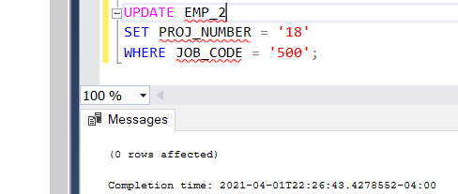

NOTE: There were no entries with JOB_CODE = ‘ 500’ as they were changed to different values in the previous update statements. Although the above query works fine if we have any entry with JOB_CODE = ‘500’

1. Using a single command sequence with the EMP_2 table, write the SQL code that will change the project number (PROJ_NUM) to 25 for all employees whose job classification (JOB_CODE) is 502 or higher.

Answer:

UPDATE EMP_2

SET PROJ_NUMBER = '25'

WHERE JOB_CODE >= '502';

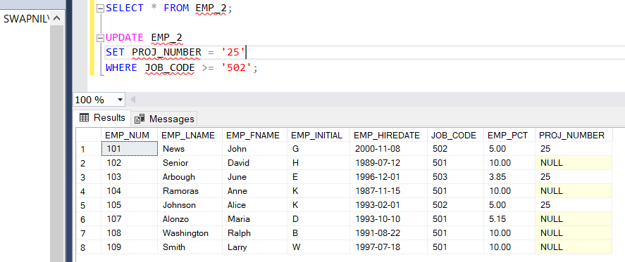

1. Write the SQL code that will change the PROJ_NUM to 14 for employees who were hired before January 1, 1994, and whose job code is at least 501. When you finish Problems 7–15, the EMP_2 table will contain the data shown in Figure P8.15.

Answer:

UPDATE EMP_2

SET PROJ_NUMBER = '14'

WHERE EMP_HIREDATE < '01/01/1994' AND JOB_CODE ='501';

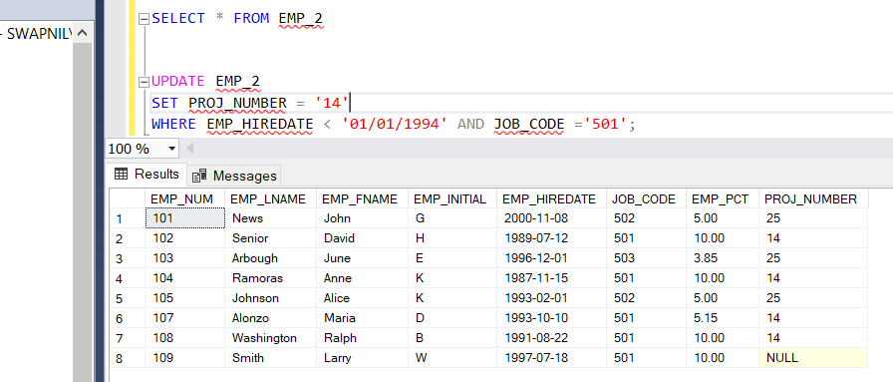

Note: Output looks the same except for the part where JOB_CODE =’500’ as it was updated previously.

1. Create the CUSTOMER table structure illustrated in Figure P8.16. The customer number should store integer values. The name attributes should support variable length character data up to 30 characters each. The customer balance should support up to six digits on the left of the decimal place and two digits to the right of the decimal place.

Answer:

CREATE TABLE CUSTOMER(

CUST_NUM INT PRIMARY KEY,

CUST_LNAME VARCHAR(30),

CUST_FNAME VARCHAR(30),

CUST_BALANCE NUMERIC(6,2)

);

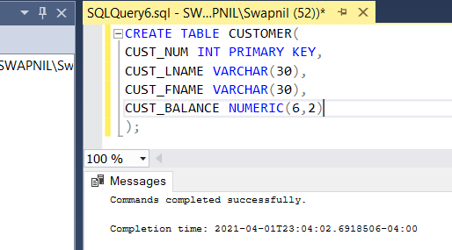

1. Create the INVOICE table structure illustrated in Figure P8.16. The invoice number should store integer values. The invoice date should store date values. The invoice amount should support up to 8 digits to the left of the decimal place and two digits to the right of the decimal place.

Answer:

CREATE TABLE INVOICE(

INV_NUM INT PRIMARY KEY,

CUST_NUM INT

CONSTRAINT FK2 FOREIGN KEY (CUST_NUM)

REFERENCES CUSTOMER (CUST_NUM),

INV_DATE DATE,

INV_AMOUNT NUMERIC(8,2)

);

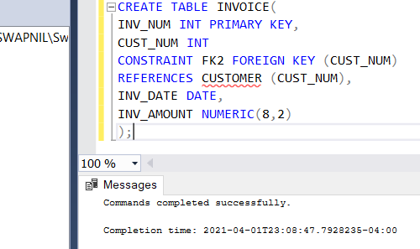

1. Write the set of SQL commands necessary to insert the data into the CUSTOMER table you created in Problem 16, as illustrated in Figure P8.16.

Answer:

INSERT INTO CUSTOMER VALUES (1000,'Smith','Jeanne',1050.11);

INSERT INTO CUSTOMER VALUES (1001,'Ortega','Juan',840.92);

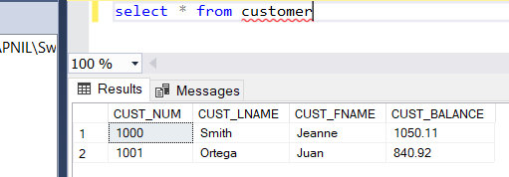

1. Write the set of SQL commands necessary to insert the data into the INVOICE table you created in Problem 17, as illustrated in Figure P8.16.

Answer:

INSERT INTO INVOICE VALUES (8000,1000,'03/23/2016',235.89);

INSERT INTO INVOICE VALUES (8001,1001,'03/23/2016',315.82);

INSERT INTO INVOICE VALUES (8002,1001,'03/30/2016',528.10);

INSERT INTO INVOICE VALUES (8003,1000,'04/12/2016',194.78);

INSERT INTO INVOICE VALUES (8004,1000,'04/23/2016',619.44);

